Nathan Hale Cross Country Parent Fan Shirts
Hello parents! Here’s a chance for you guys to be ‘All For The Cause’ and support your son and the team by buying a Hale CC fan shirt! These shirts will be green with white print, and are the same shirts that your son will be given to keep and wear for warm-ups on race day. We can be a force out at meets and show our support. Let us know what you would like on the back, and the size. Each shirt will cost $15.00 with extra revenue going to the team fund.
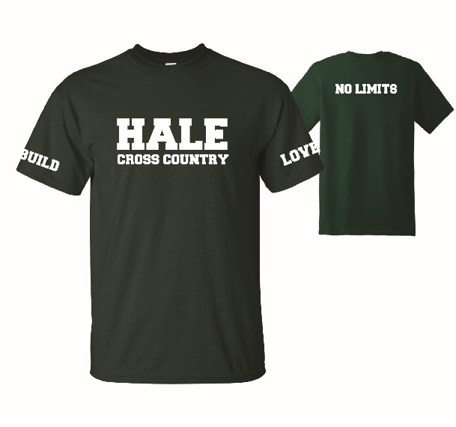
Fill in for as many shirts as you’d like to buy, if you choose no name on back then it will say ‘no limits’, use additional sheets or back for more.
Name on Back: __________________________________
Size: ______________________
Name on Back: __________________________________
Size: ______________________
Name on Back: __________________________________
Size: ______________________
Name on Back: __________________________________
Size: ______________________
Name on Back: __________________________________
Size: ______________________
Please return to Mach by Friday, August 23rd with money. Checks payable to Nathan Hale Boys Cross Country

