Nutrition Notes.
How to Fuel
- Start every morning with water.
- Breakfast is most important meal, replaces lost nutrients during sleep. Add cinnamon to any toast or any food. Eggs are good.
- Healthy foods are fresh fruits, vegetables, beans, eggs, real cheese, whole meat (fish, beef, chicken), nuts, seeds.
- Eat frequently rather than focusing on big meals.
- Dark greens and lots of colorful vegetables. If you know directly where it came from it is probably better for you.
- Increase mineral intake from veggies, rice and grains.
- AVOID JUNK FOOD! As a runner, it is easy to be attracted to high sugar snacks and candy. These slow you down. Dark chocolate is okay and can satisfy this urge.
- Get calories from chicken, fish, almonds and nutrition foods instead of junk food and things such as white bread.
- Consistent doses of protein throughout the day.
- Practice what works for you. Eat smart lunches and avoid dairy and high fiber foods at school. Turkey sandwiches, pb/jelly sandwiches, salads, a small snack, water! Avoid milk, candy, processed foods.
Refuel - Post Run
Within a half hour after working out, speed recovery and repair by consuming 40-50 grams of carbohydrate, and 10-20 grams of protein. Recovery items to consider - P.B. and banana, chocolate milk, natural energy bar and gatorade.
Get a good meal with protein after hard workouts/races! Eat about 1-1.5 hours after running.
Sinuses are acting up?
- Try a shower blasting hot and cold water at 30 second intervals. This is also good for muscles.
- Drink tea! Cold medicines might help you sleep but mainly just make you tired.
KEEP IRON LEVELS UP
- Sources = Red meat, raisins, prunes, spinach, cereals. Best absorbed with Vitamin C.
Vitamin D is also important!
- Can be good for growing pains and stress fracture avoidance.
Night Time
- Take study breaks, stand up, walk, jumping jacks.
- Avoid TV, phones and electronics after 8 p.m. READ BOOKS!!!
- Get 8-9 hours of sleep a night. More is needed the harder your efforts.
- Attempt to go to sleep at a similar time each night if possible.
- 20 g. protein before bed can help in recovery on hard days
- 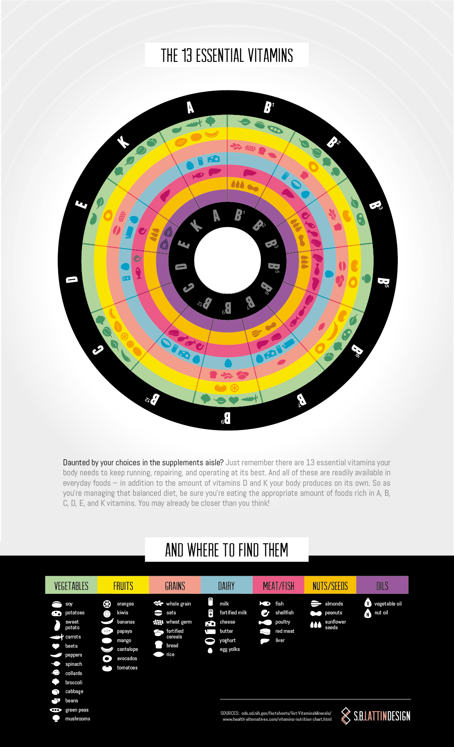

- 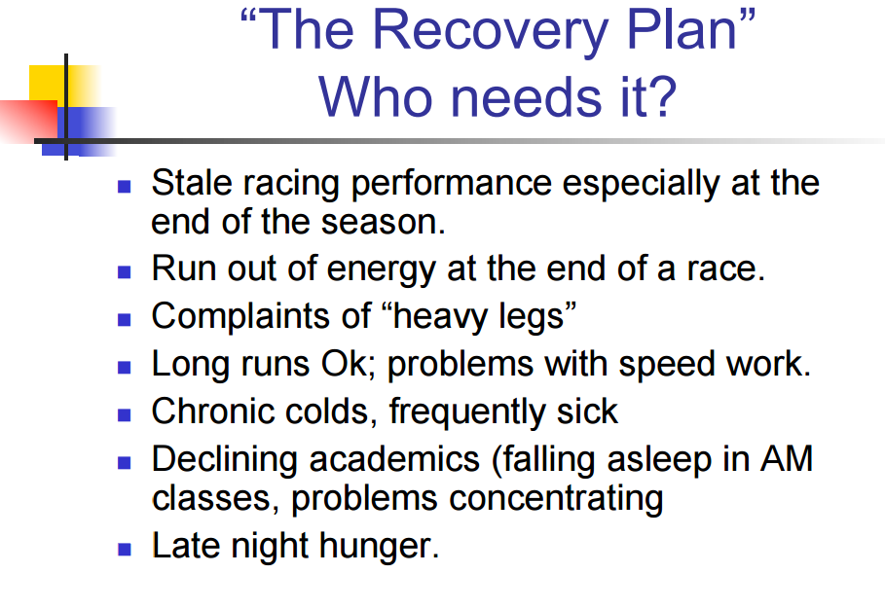
- 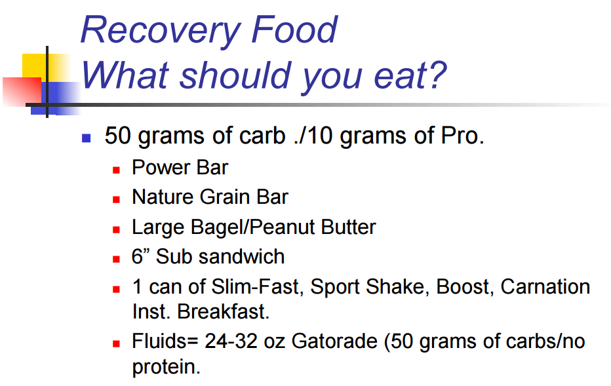

- 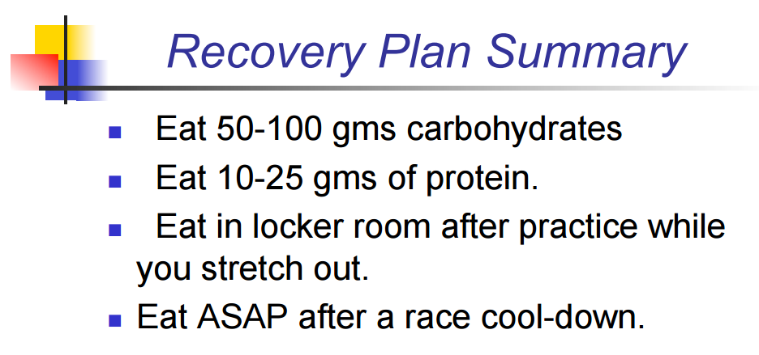

- 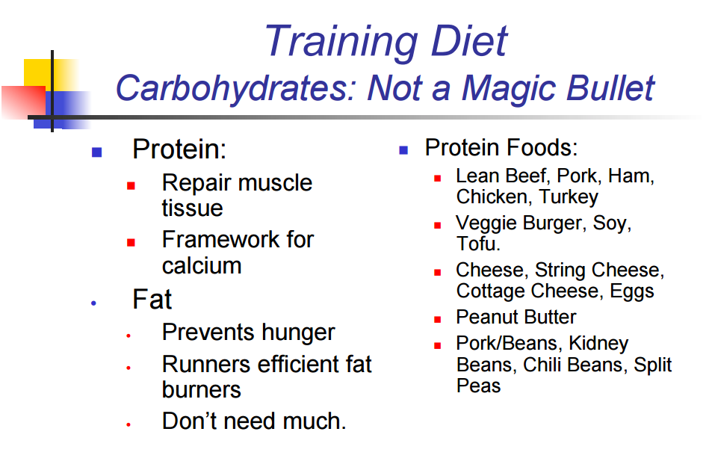
- Also Add to diet -
- Calcium, vitamin D (Milk) every day
- Red meats 3x a week (small servings for IRON) (Hamburger, pork, beans, veggie burger)
- 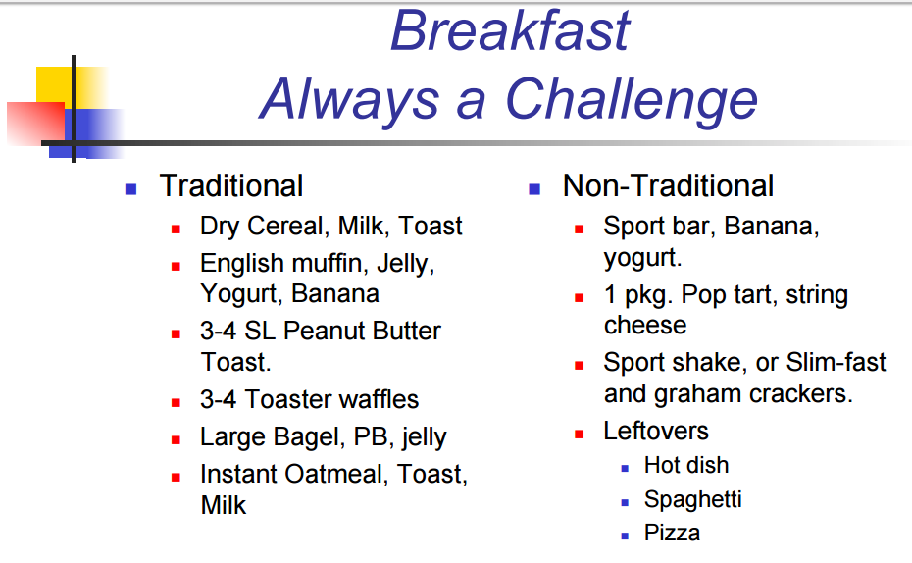

- Don't ask "What if?" after high school or college. Make changes now to make you race better.

