Hale Track Nutrition, Sleep and Healthy Habits
Summary
Sleep! - Sleep is the ultimate performance enhancer. Check out the end of this for a few notes and tips on sleep.
Wash your hands! After bathroom, before eating, and any other times you interact. Due to spread of germs, let’s do fist bumps instead of handshakes.
Avoid sharing cups/bottles and food.
Carbohydrates – Unless diabetic, carbohydrates are essential fuel for athletes. You will want to have carbs within each meal and spread through the day with snacks.
Iron/Ferratin Levels –Especially for higher mileage athletes. Red meat is the best source of iron. Spinach, cereals and beans have iron but not as impactful. Please read at the end of this document two important links on iron for runners. This one is vital to stay on top of, especially for guys/girls doing mileage of 40 or more.
Protein –A rebuilder and repair element of nutrition. Preferably those who can will eat protein in the form of meat. There’s protein in many foods you’ll eat such as nuts, eggs and dairy products too.
Please save and look at the articles at the end of this document for details on carbs, protein and iron
Dairy – For those that are able to stomach it, dairy is great as it provides carbs and protein! Milk, REAL cheese (preferably not pre shredded or processed) and Greek Yogurt (add fruits/nuts) are good and healthy fuels.
Vitamin D – Cheap supplement and can help with growing pains and bone health! Many people are deficient, sunlight is best way to get it but winter can be tough in WI.
Water – Drink consistently with meals. No need to over hydrate and slam water, but be consistent throughout the day. When you wake up have a glass, then drink consistently through the day. Avoid sodas, energy drinks and any other juices or sugary drinks! They are negative in every way. Energy drinks are absolutely toxic, try extra sleep instead!
Do not follow a specific diet, instead be balanced, eat natural foods (from animals or Earth) and avoid processed and sugary foods as much as possible. Talk to coach if you struggle with carb/protein and nutrient intakes from being diabetic, gluten intolerant or vegetarian. There are plenty of options for every person.
Don’t count calories, just eat often and focus on hitting the big 3 meals with variety through each day and week. Food is fuel, we burn a lot of calories as teenage athletes so we need to eat a lot more food than normal people. The more we run, the more we need to eat! Eat often and eat well.
Nutrients from food is what we want. Supplements are not the same, and outside of looking at adding vitamin D or iron supplements, no other vitamins or supplements take the place of FOOD!
We take care of our cars with the proper fuel, but we often fuel our bodies with junk food and processed sugars. It’s very easy to avoid this with a little thought and planning.
Avoid eating fast foods, take time to prepare snacks and cook your own food. Will know what you are eating and can avoid processed artificial ingredients and excess sugars.
What to Eat?
Below is a menu for teen athletes to look at. The key is balance and making sure to eat every meal AND also to snack through the day. We can’t afford to run on low fuel. Always be open and talk with Mach if you are struggling with nutrition, whether it be missing meals or feeling constricted on what you eat. There are many options for any type of person. I’m a picky eater as well, but I find what works for me and what’s healthy and I go all in on eating those foods and often. Food gives us power. This list obviously isn’t comprehensive, but hopefully helps give a plan. Feel free to reach out and ask about any foods.
Breakfast!
Eat a strong and FILLING breakfast, pair some items together. Do not skip breakfast! At the worst, reheat leftovers in the a.m. if needed, otherwise plan ahead so you aren’t rushed in the morning. It’s easy to precook foods the day before! I often cook bacon, eggs and sausage at night time for the morning. Easy to heat up and eat as a sandwich on days you are on the go.
Eggs – powerful breakfast! Recommend 2-3 eggs.
Toast & pb, add cinnamon to any toast or foods
Sausage patty
Bacon
Fruits – Orange, apple, banana, grapefruit
Greek yogurt w/ fruit in it
Oatmeal w/ milk
Orange juice, milk, water. Be sure to have a cup of water when you wake up.
Sample Breakfasts:
2-3 Eggs, 2 strips of bacon, apple slices, orange juice
Oatmeal, 2 slices of pb toast, banana, milk
Whole wheat bagel w/ nut butter, yogurt w/fruit, milk
Breakfast should NOT just be a bowl of cereal. Use cereal as a snack, especially at night time. Cereal will leave athlete’s feeling hungry as it’s not a filling breakfast meal. But definitely eat something in the morning. That’s better than nothing!
I find A LOT of our athletes skip breakfast. Eating breakfast is necessary to maximizing performance, and it’s a simple way to improve!
And, continue to snack between meals..
SNACKS: Snacking is key outside the 3 meals. Here are some simple and healthy snacks to pack each day. Parents be sure to understand and allow your son/daughter to snack when they want. They will be hungrier than the average hungry teen, and they NEED to snack and eat more. Let them eat often, and help them keep it healthy. Rather than oreos, cookies or sugary stuff, pack these items daily for school,
Nut butters (peanut butter or almond butter) on apple slices
Bananas –
Celery sticks, carrots, grapes
KIND bars, healthy granola bars – Nature valley are okay as well.
Greek yogurt – can add in walnuts or almonds or both! Or add fruit.
Hard boiled egg w/ fruit or avocado
Cheese sticks w/ lunch meat wrapped around
Chex Mix / Nuts.
Lunch
Turkey sandwich
Peanut butter (&jelly) sandwich
Tuna Sandwich
Bean burrito
Salad w/ protein (quinoa really easy to prepare and vegetarian option, chicken also easy to prepare and add to salad), have w/ home made dressing or light store bought dressing. Add in other healthy toppings, rice, green peppers, fruits, veggies.
Dinner leftovers (make sure sits well in stomach, avoid ‘heavier’ meal)
Fruits – oranges, banana, apple
Carrots w/ nut butter to dip in
Yogurt
Trail mix
Granola Bar – look for KIND bars or Nature valley protein bar with pb and dark chocolate

Sample Lunches
Turkey sandwich, muffin, apple, water
Quinoa or chicken salad, yogurt, granola bar, water
Leftover fish taco, carrots w/ peanut butter, water
PB sandwich, banana, trail mix, water
(I like water during the day and milk for morning and night for stomach purposes at practice)

Post run: Look at the snacks list. Within a half hour after run look to take in carbs and protein for recovery and building. 40-50 grams of carbohydrate with 10-20 gram of protein good in this window.
Example Post run – Banana and chocolate milk
Natural energy bar (KIND bar or home made bar) and Gatorade

Dinner
Meat w/ at least 25-30 grams of protein
Red meats 3 times a week – IRON + possible supplementing opposite days. Red meats will allow more iron absorption if eaten without calcium or cheese.
Chicken Breast (try wrapping bacon with it )
Pulled pork
Chili
Hamburger (NOT Mcdonalds or culvers, grill or make own bison or ground beef at home)
Bean (and rice?) Burrito – vegan choice
Tuna Sandwich
Fish – Salmon or Cod (Great in fish tacos)
Whole wheat pasta – top w/ chicken or ground beef meat sauce or meatballs or make marinara if vegan
Zucchini pesto pasta is good for gluten free vegetarian option
Squash (another no meat option, lots can make with it and can mix with meat too)
Macaroni w/ real cheese and broccoli (add in broccoli with noodles) (vegan option)
Pizza – Instead of frozen, look to buy or make own healthy crust, add sauce (simply can be can of crushed tomatoes) and real cheeses and toppings. (vegan option when topped with leaves and veggies)
A few dinner Sides-
Sweet Potatoes
Vegetables – salad or add broccoli, spinach or green beans to meal. Any vegetables you will eat with dinner is great.
Wheat crackers, peanut butter
Tomato soup or broth based soups
Oatmeal
Rice
Pretzels
Some post dinner bowl of ice cream to help add calories! Some other go to’s - Dark 85% cocoa chocolate in small amounts can help fill sweet tooth and don’t be afraid to have cookie once and a while, just limit these foods and put emphasis on real foods to fill the tank.
Sample Dinners: Mix and match entrees w/ healthy side and milk or water
Fish/meet tacos – cut up cod or ground beef with veggies, salad, milk
Lasagna with meat, salad, sweet potatoes, milk
Macaroni w/ broccoli, salad, pretzels, ice cream, water
Snacks before bed:
Cereal w/ milk
Yogurt
Oatmeal w/ walnuts
Crackers or pretzels w/ cheese

Night Time SLEEP (See sleep notes – last section of pdf)

Resources
Diet is important, and along with sleep and running, can ward off and nearly eliminate most any health issue. As parents of teen athletes, you can help build strong athletes simply through providing health conscious choices, good snacks, and 3 well rounded meals.
Some simple books for runners and mainly parents of runners I’d recommend are books by Shalane Flanagan (one of the all time best female distance runners in America). Her books are called,
Run Fast. Eat Slow
Run Fast. Cook Fast. Eat Slow.
They may guide some ideas, and they have tons of vegan and gluten free options too for those that need. I’m actually not a huge meat eater, but am sure to add to my diet as it enhances running performance. Don’t worry if you don’t like specific foods, just get really good at eating healthy ones you can eat, and slowly expand your selections. It takes time! I own both of these books and happy to share any time. Just ask!

Parents check out these articles to help guide proper nutritional intake for athletes,
https://nutritionwithwendi.com/blog/carbohydrate-and-protein-needs-for-young-athletes-desiring-to-make-the-jump-from-good-to-great/
Iron Intake (Important article for guys that are getting to 40+ miles a week),
http://www.runningwritings.com/2017/04/low-ferritin-and-iron-deficiency-anemia.html
How to best absorb Iron (Important article for those 40+ miles a week),
https://trainright.com/nutrient-timing-guide-optimize-iron-absorption/

Iron (Distance focus)
Read the above links on iron. A supplement is also advised for those doing mileage of 40 or more miles, taken about every other day. Look for supplements in the form of heme iron. If that’s too expensive, there are cheaper ones like Solgar’s Gentle Iron. That’s not heme, but it’s gentle on the stomach. It is extremely hard to take too much iron, and easy to become deficient as a runner. I recommend ferratin levels get tested ahead (need to tell doctors ferratin levels, not just iron otherwise they won’t test) of seasons as a benchmark, but regardless every athlete should focus on iron intake daily.
Sleeping IS training
When you sleep 8 hours…
Significantly reduce risk of injury
Stronger body – (body repairs and builds during sleeping hours)
Increase time to physical exhaustion
Aerobic output significantly increased
Improve and strengthen what you learn
Improve skill memories
Improved memory
More creativity
Be able to take in more information at school (means less effort and more learning!)
Better mood, less anxiety, more patience, high self esteem
Improved efficiency and productivity
Long-term health, greatly reduced risks of disease and cancer
Tips:
Stick to a consistent bed time as much as you can Just like running, build routine!
Don’t use phone/computers/tv within 1 hour of going to bed. Use time to relax and rewind, read a book, journal your day. The light from screens will keep you awake.
If you’re currently sleeping way less than 8 hours, then gradually add in time for sleep. Start with 15 minutes a night for a week and improve from there.
Afternoon weekend naps are good, but not over 45 minutes and not after 4:00 p.m.!
Don’t stress over it, just work towards being more consistent!
Some nights may not be as great of sleep, but don’t worry just be as consistent as you can and build towards more sleep over time!
One more passage from the book ‘The Teenage Brain’,
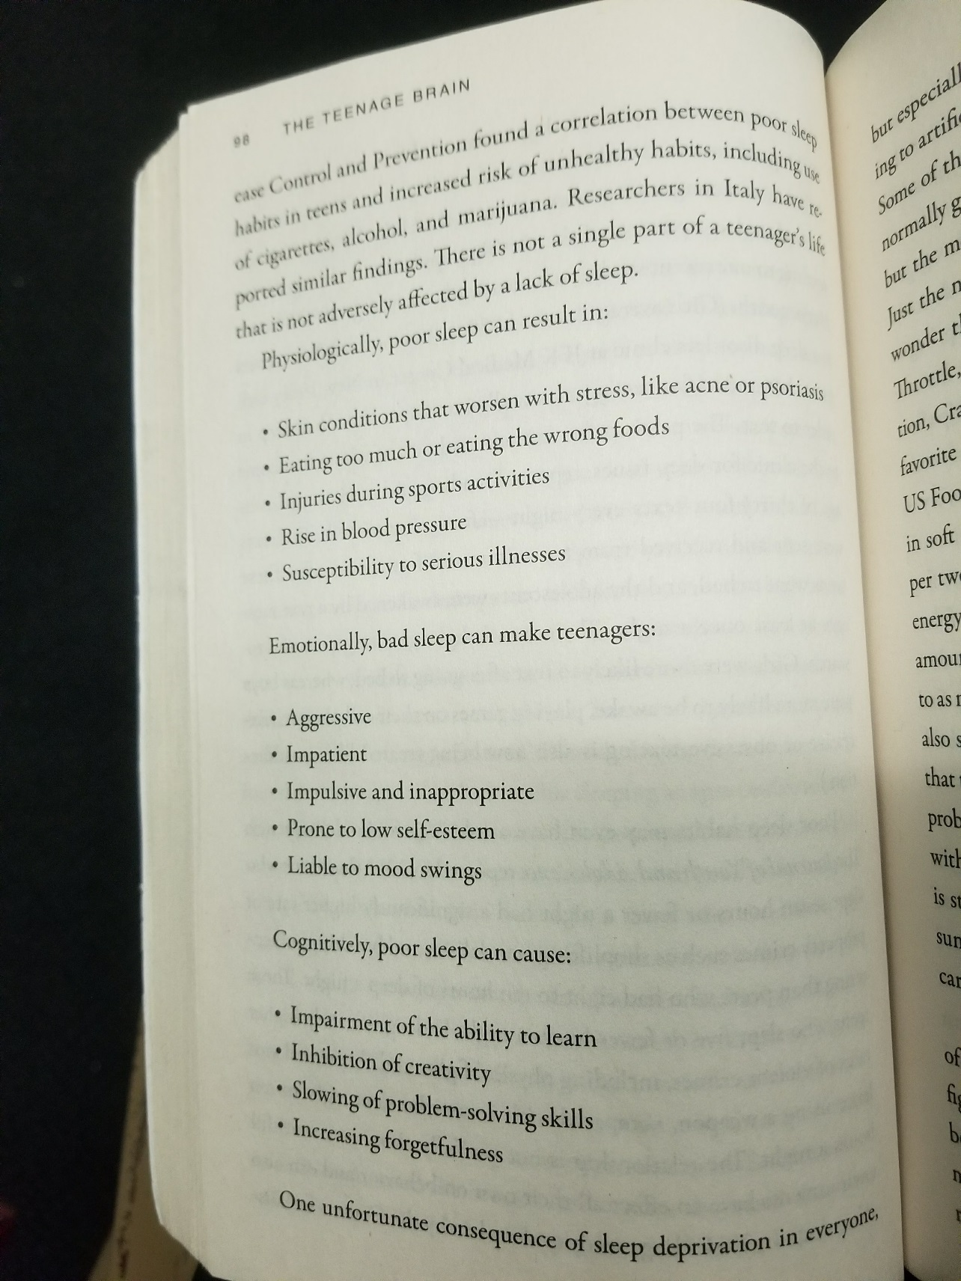

Here’s a table for those looking to maximize school and athletic performance. As an example of a 7:00 a.m. wake up time for school, 10:00 p.m. is a good benchmark for good sleep, with 10:30 being solid. Teens brains have a little later clock than adults, but the biggest thing is to avoid screen time (phone, laptop, videogame, tv) at least an hour before bed time.

